Design: Open Interest

Overview

Current processing
Currently in production OpenInterest is loaded for CFE, ONE and COF products – but this is done at EOD unlike the OpenInterest for W_Main which will be loaded early in the morning.

New requirement
CBOEDirect needs to load open interest from the table SBT_OPT_OCC_OPEN_INT early in the morning into its own PRODUCT table.
To get the openInterest data for W_Main products into the PRODUCT table and ensure that it is propagated to all processes the following changes need to be made.

Implementation





CBOEDirect
Global Cluster
DWH
CDB
Global Server
Product Maintenance
Service
OCC
SA CAS
SA GUI
PRODUCT
GC Database
Open
Interest
Open
Interest
Open
Interest
Help Desk
Following are the steps to achieve this requirement.
- Load the W_Main products Open Interest data from OCC into CBOE Direct GC database.(please refer ‘DataBase(.5)’ section)
- Update the Open Interest data into PRODUCT table in GC
- Publish the Product (with open interest data) for the consumers that require the Open Interest data.

Update the Open Interest data into PRODUCT table in GC
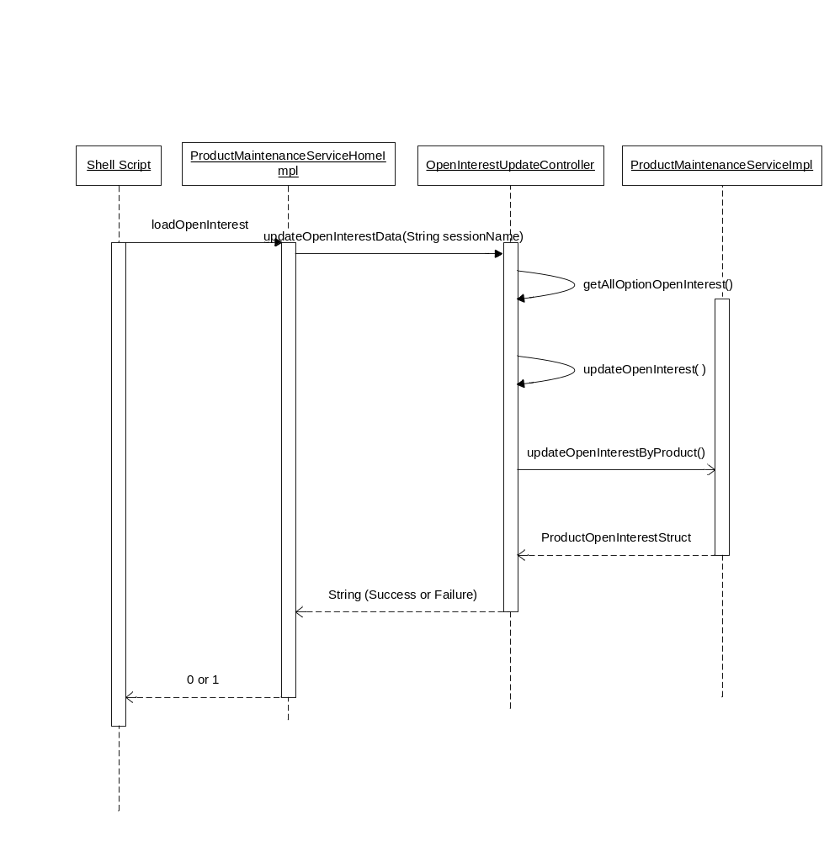
Figure: Sequence Diagram.

Modify existing loadOpenInterest.sh script and pass the session (W_Main) as a parameter to load open interest data for W_Main products. To achieving this, following steps need to be performed.
- Use the ‘loadOpenInterest ‘ AR command: In com.cboe.internalBusinessServices.productService.ProductMaintenanceServiceHomeImpl-
initialize() method, will register the open OpenInterestUpdateController with the updateOpenInterestData command.

- Modify the signature of the method called by the AR command to add String argument: updateOpenInterestData(String sessionName) in com.cboe.internalBusinessServices.productService.OpenInterestUpdateController
  - If the input argument is null or other then W_Main method will call updateFutureOpenInterestData(); updateOptionOpenInterestData(); method of same class.
  - If the input argument is W_ MAIN, method will call updateAllOptionsOpenInterestData(String sessionName) of the same class. This method will intern call getAllOptionsOpenInterest(); to get latest open interest data for W_Main OPTIONS.
  - Get sessionClasses = BusinessServicesHelper.getTradingSessionService().getClassesBySessionForType( of TradingSessionService.
  - After getting the latest data and sessionClasses , threads will be started (total no of threads = total thread pool size) pool size has taken from the property file for updating the open interest data into product table. Each thread equally divides the classes and updates the open interest data for W_Main session into product table.
  - Each thread will do the following
    - For each SessionProductStruct struct do the following:
      - Get the Reporting Class Struct from sessionClasses
      - Get all the allOptionOpenInterestData from the map for this Class using the Reporting Class Symbols.
      - Create the ProductOpenInterestStruct from the OptionsOpenInterestData by calling create method of same class
    - After getting ProductOpenInterestStruct []. Call the updateOpenInterest(int classKey, ProductOpenInterestStruct[] productOpenInterests) method which interns calls ProductOpenInterestStruct[] updateOpenInterestByProduct(int classKey final ProductOpenInterestStruct [] openInterest ) of com.cboe.internalBusinessServices.productService.ProductMaintenanceServiceImpl class that persists the struct into database.
    - After successful updating publishOptionOpenInterestData method will be called by using productMaintenancePublish object for publishing the ProductOpenInterestStruct on product status event channel.
    - The code logs the total number of threads
    - The code logs a progress report for every 10% complete of total number of records update
    - The code logs reports for products which are not updated.
    - After the 100% completion code displays the list of all the products which are not updated.
    - The code publishes the data on event channel for consumer that requires the open interest data. For detail refer Section below.
  - This method should log & return a string indicating “SUCCESS” or “FAILURE”.
  - Use releaseOptionsOpenInterestLock AR command for releasing a lock for Open Interest Update Progression.

Publish Product (with open interest data) for the consumers that require the Open Interest data
Publish data for open interest, per class over the ProductStatus channel so other processes can pick it up in case they came up before OCC has sent us the data.
- ProductStatusChannel is the name of the Event Channel.
- OpenInterestUpdateController will call the find method of ProductStatusConsumerHomeImpl which will create/find and return ProductStatusPublisher object. It will then invoke ProductStatusPublisher. updateProductOpenInterest (classkey, productOpenInterestStruct) method.
- MareketDataReportService is the only consumer which will consume the event. It’ll will use addConsumer() method of ProductStatusConsumerHomeImpl class for consuming the Event published on event channel.
- Implementation of updateProductOpenInterest () method needs to be added in com.cboe.server.events ProductStatusConsumerImpl class which will delegate the call to the final consumers like MareketDataReportService.
- New method updateProductOpenInterest () needs to be added in MareketDataReportService.

Scripts(2)
- Shell script “SchedOCCoPenIntSBTLd_B” which will intern call the sql script POPULATE_ SBT_OPT_DDS_OPEN_INT_T. This SQL Script is used to populate open interest data for CBOE products only into SBT_OPT_DDS_OPEN_INT_T by making a join on OPT_DDS_OPEN_INT and SERIES_ARCH_T.
- Shell script “refresh_sbtgp00_histp01_opnint.sh” will refresh SBT_OPT_DDS_OPEN_INT_SN snapshot.
- Modify existing loadOpenInterest.sh script and pass the session as a parameter to load existing and W_Main products.
- The script should always return status codes of 0 or non-zero depending upon success or failure of the execution.
- The script should do the following validations before calling the above “ar” command and should return a non-zero status if any of these checks below fail.
- This script should be allowed to run only on the GC box.
- This script should check to see if the GlobalServer process is up and running.
- After the “ar” command is executed the script should return a status of 0 if the return output from the “ar” command is SUCCESS or a non-zero value if the output of the ar command is not-success.
- Create a new Shell script “releaseOptionsOpenInterestLock” which will call the AR command releaseOptionsOpenInterestLock for releasing the lock for open Interest Update.
- This script should be allowed to run only on the GC box.
- This script should check to see if the GlobalServer process is up and running.
- After the “ar” command is executed the script should return a string with message “Options Open Interest Lock Released ”

.

Database(.5)
Getting Data From OCC to DWH to CBOE Direct GC database. For achieving this, following steps needs to be done.
Existing Tables

  - OPT_DDS_OPEN_INT_T Table contains data for all the Exchanges which is send by OCC to DWH.
  - SERIES_ARCH_T table contains products data which are traded at CBOE .

Step1 : Data Filtering for W_Main products and loading into
SBT_OPT_DDS_OPEN_INT_T table
  - Control M Script “SchedOCCoPenIntSBTLd_B” will call the shell script “SchedOCCoPenIntSBTLd_B” which will intern call the sql script OCCoOpenIntSBTLoad.sql. This SQL Script is used to populate open interest data for CBOE products only into SBT_OPT_DDS_OPEN_INT_T by making a join on OPT_DDS_OPEN_INT _T and SERIES_ARCH_T.

Step2 : DWH to CBOEDirect GC Database

  - Snapshot SBT_OPT_DDS_OPEN_INT_SN under DW-OWNER in SBTGP00 database. This snapshot will be same as on SBT_OBT_DDS_OPEN_INT_T table in DWH.
  - View SBT_OPT_OPEN_INT_V is created on SBT_OPT_DDS_OPEN_INT_SN.
  - A public synonym with read-only access, SBT_OPT_DDS_OPEN_INT will be created for SBT_OPT_DDS_OPEN_INT_V view. Control M Script “refresh_sbtgp00_histp01_opnint” will call shell script “refresh_sbtgp00_histp01_opnint.sh” which will refresh SBT_OPT_DDS_OPEN_INT_SN snapshot.

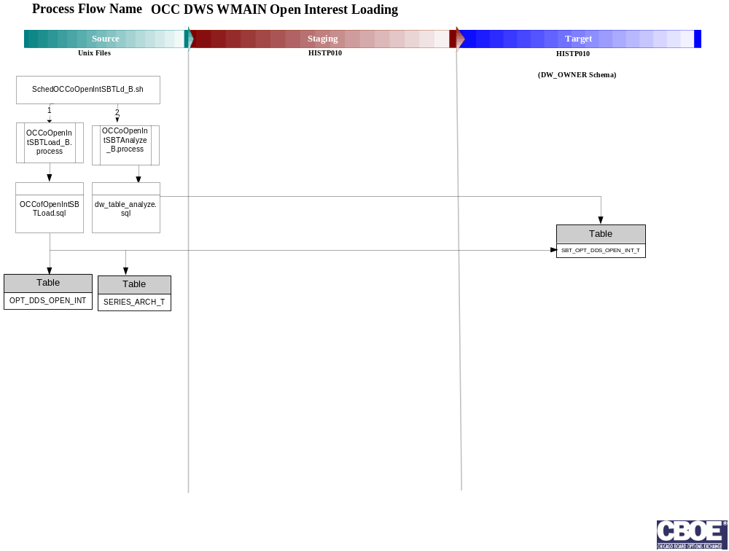
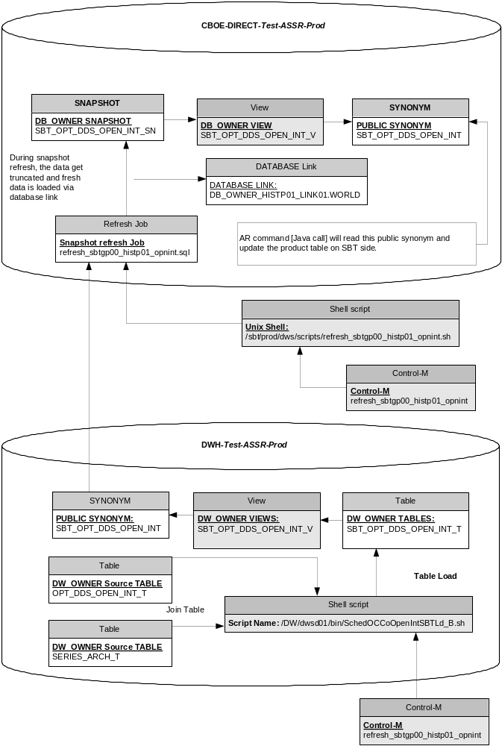
Figure: Data flow from OCC to CBOE Direct.

SetContext(.125)
- None

XML/DTD(.5)
- ProductMaintenanceService.dtd
- GlobalServer.xml
- ProductMaintenanceService.xml

Homes/Services(4)
- ProductMaintenanceServiceHomeImpl
- OpenInterestUpdateController
- AllOptionsOpenInterestDataImpl.
- AllOptionsOpenInterestDataHome.
- AllOptionsOpenInterestDataHomeImpl.
- ProductMaintenanceServiceImpl.
- Product.
- ProgressLogger

Scripts(5)
- loadOpenInterest
- releaseOptionsOpenInterestLock

PerformanceTestingProcedure(1)
- List all scenarios here.

TestingProcedure(1)
- List all scenarios here.

OperatorProcedure(.5)
- NA

Fallback/Failover
- NA

Open Issues
- Control M Script dependency. i.e. one should run the control M script of CBOE database side after data loaded into DWH side.
- User id and password for Database as well as DWH connection
- UNIX id’s to run the shell scripts on UNIX box.
- What if the data are not loaded into the database
- We have identified MareketDataReportService is the only consumer which will consumes the event published on ProductStatus channel

Appendix:

